Horizontal Cross Section

Definition
# Source: AI Source: Provided by: [Data Path: Persons Table -> ID Column: 1, Name_En Column: Motasem Essam] -> From: [ChatGPT] on [7/25/2026]
A Horizontal Cross Section is a two-dimensional geometric figure formed when a solid is intersected by a horizontal plane, generally parallel to its base.
The resulting cross-section reveals the shape of the solid at a particular height.
The shape and dimensions of a horizontal cross-section depend on:
- The geometric shape of the solid.
- The height at which the cutting plane intersects the solid.
- The dimensions of the solid at that height.
- Whether the solid has uniform or varying cross-sectional dimensions.
For example:
- A horizontal cross-section of a cylinder is a circle.
- A horizontal cross-section of a rectangular prism is a rectangle.
- A horizontal cross-section of a cone is a circle whose radius depends on the cutting height.
- A horizontal cross-section of a pyramid is a polygon similar to its base.
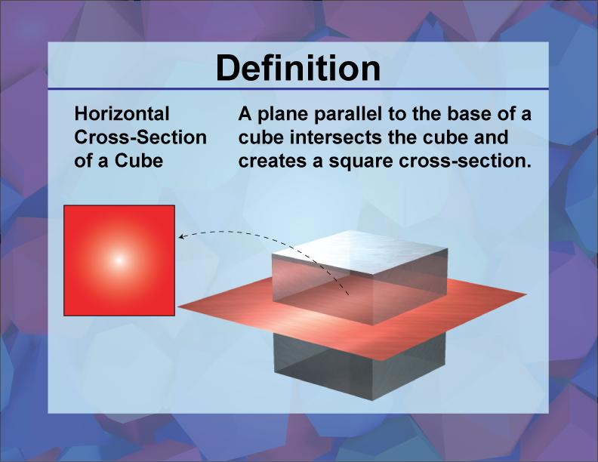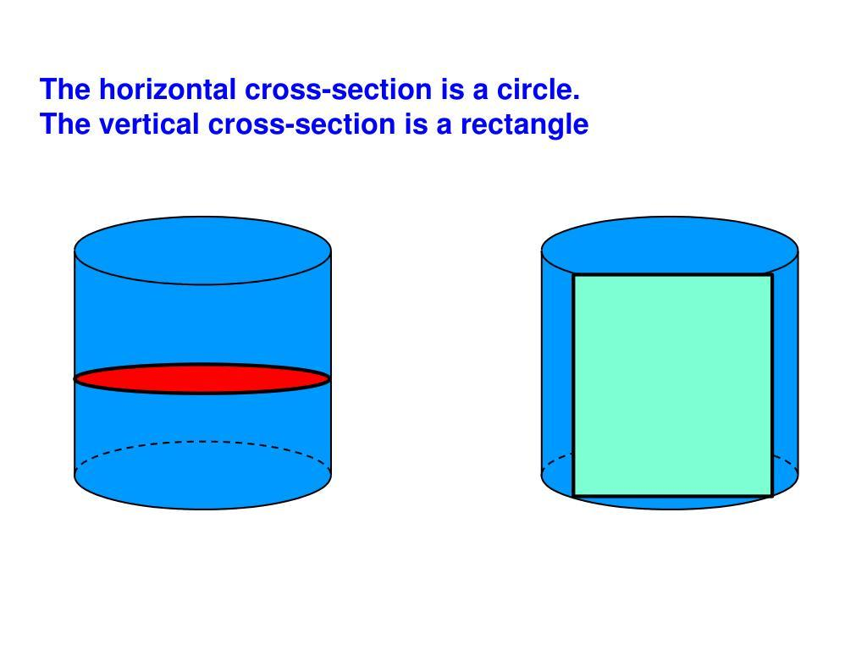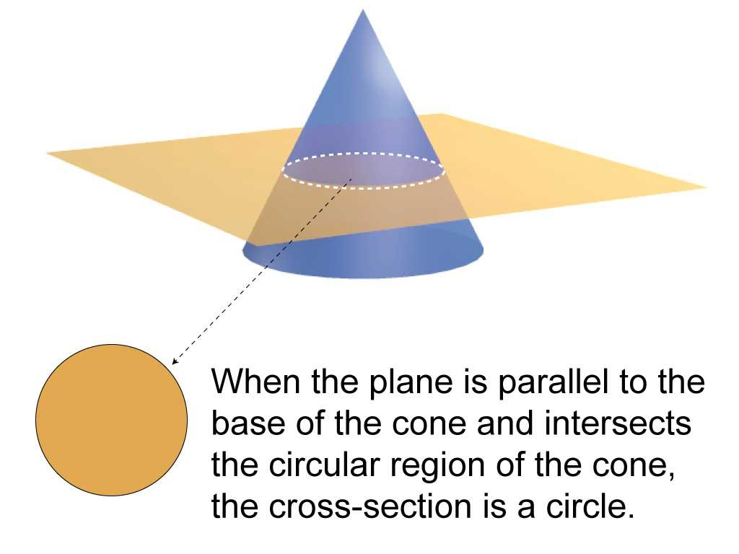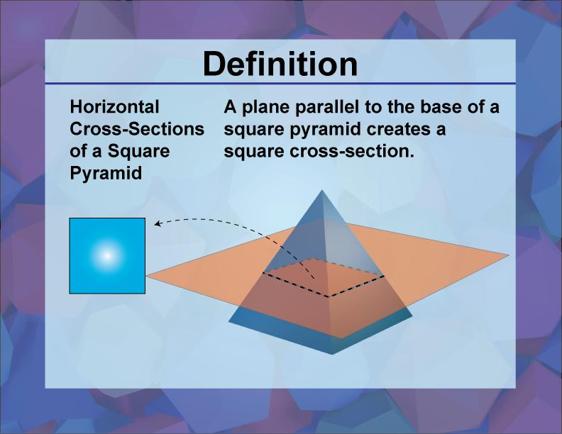

Geometric Structure
# Source: AI Source: Provided by: [Data Path: Persons Table -> ID Column: 1, Name_En Column: Motasem Essam] -> From: [ChatGPT] on [7/25/2026]
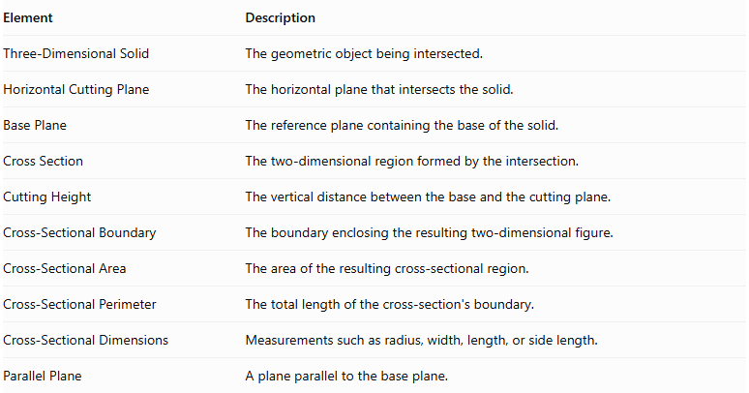
Element | Description
Three-Dimensional Solid | The geometric object being intersected.
Horizontal Cutting Plane | The horizontal plane that intersects the solid.
Base Plane | The reference plane containing the base of the solid.
Cross Section | The two-dimensional region formed by the intersection.
Cutting Height | The vertical distance between the base and the cutting plane.
Cross-Sectional Boundary | The boundary enclosing the resulting two-dimensional figure.
Cross-Sectional Area | The area of the resulting cross-sectional region.
Cross-Sectional Perimeter | The total length of the cross-section's boundary.
Cross-Sectional Dimensions | Measurements such as radius, width, length, or side length.
Parallel Plane | A plane parallel to the base plane.

Main Characteristics
# Source: AI Source: Provided by: [Data Path: Persons Table -> ID Column: 1, Name_En Column: Motasem Essam] -> From: [ChatGPT] on [7/25/2026]
- The cutting plane is horizontal.
- In the standard upright-solid convention, it is parallel to the base.
- The cross-section is a two-dimensional figure.
- Its shape is determined by the geometry of the solid.
- Its dimensions may remain constant or change with the cutting height.
- Cross-sections of a prism parallel to its bases are congruent to the bases.
- Cross-sections of a pyramid parallel to its base are similar to the base.
- A horizontal plane can intersect a solid at different heights, producing different cross-sectional sizes.

Types of Horizontal Cross Sections According to Geometric Shape

Polygonal Horizontal Cross Section
# Source: AI Source: Provided by: [Data Path: Persons Table -> ID Column: 1, Name_En Column: Motasem Essam] -> From: [ChatGPT] on [7/25/2026]
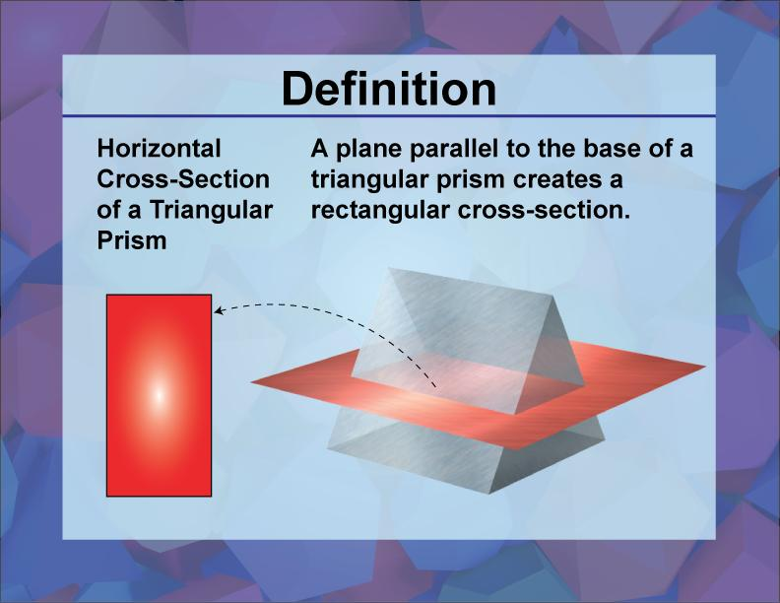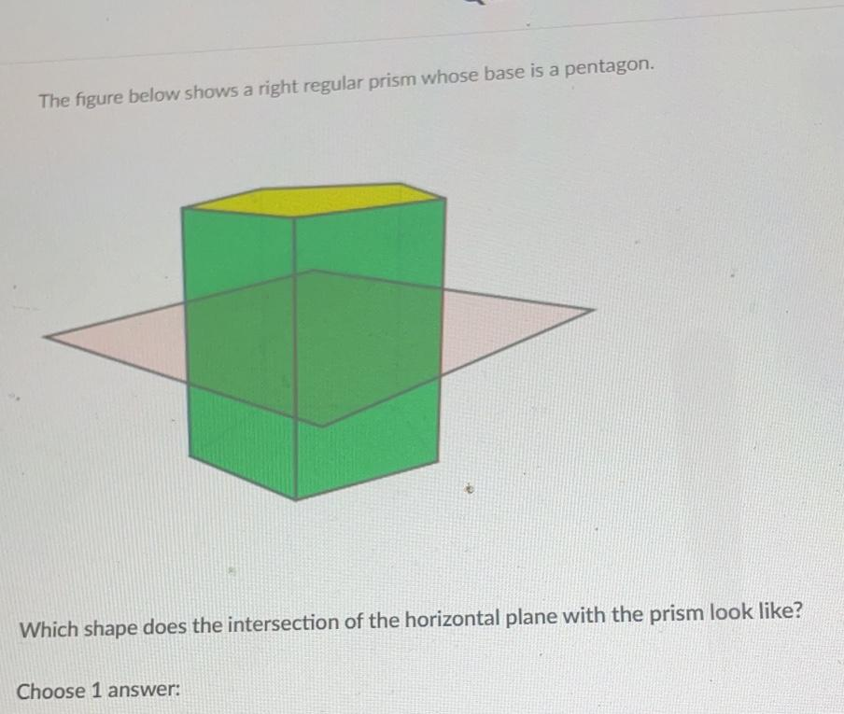
A Polygonal Horizontal Cross Section is formed when a horizontal plane intersects a solid and produces a polygon.
Examples:
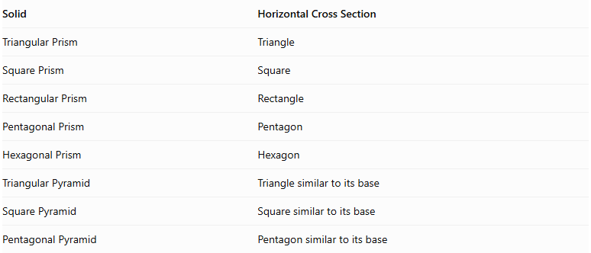
Solid | Horizontal Cross Section
Triangular Prism | Triangle
Square Prism | Square
Rectangular Prism | Rectangle
Pentagonal Prism | Pentagon
Hexagonal Prism | Hexagon
Triangular Pyramid | Triangle similar to its base
Square Pyramid | Square similar to its base
Pentagonal Pyramid | Pentagon similar to its base
Important properties:
- In a prism, horizontal cross-sections parallel to the bases are congruent to the bases.
- In a pyramid, horizontal cross-sections parallel to the base are similar to the base.
- For a pyramid, the cross-sectional dimensions decrease as the cutting plane approaches the apex.

Circular Horizontal Cross Section
# Source: AI Source: Provided by: [Data Path: Persons Table -> ID Column: 1, Name_En Column: Motasem Essam] -> From: [ChatGPT] on [7/25/2026]
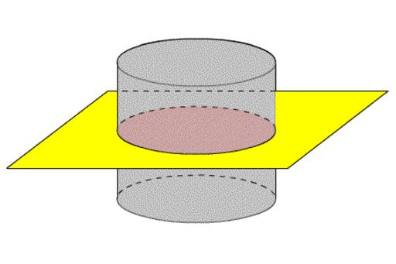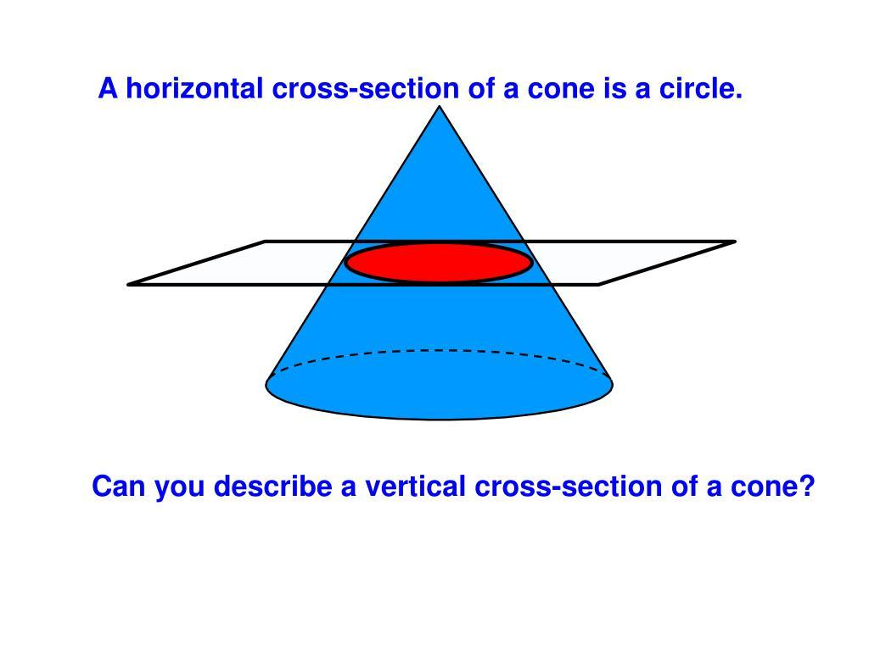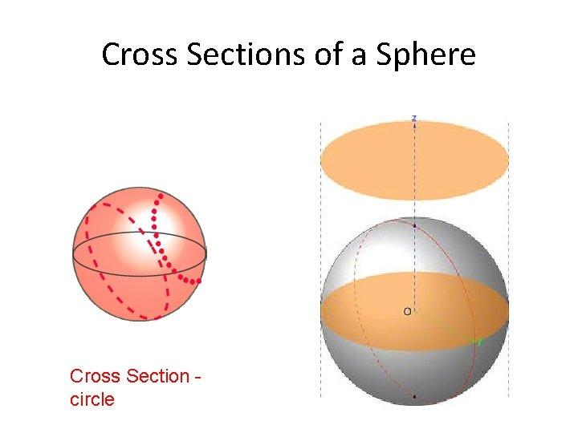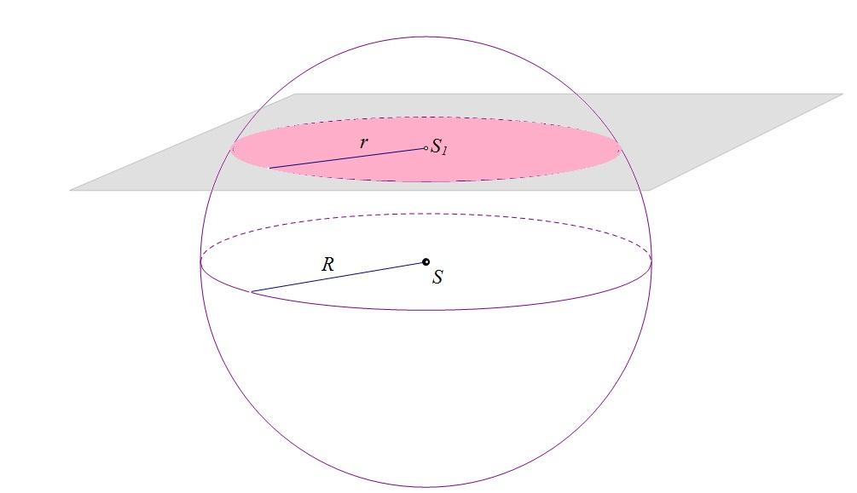
A Circular Horizontal Cross Section is formed when a horizontal plane intersects a curved solid and produces a circular region.
Examples:
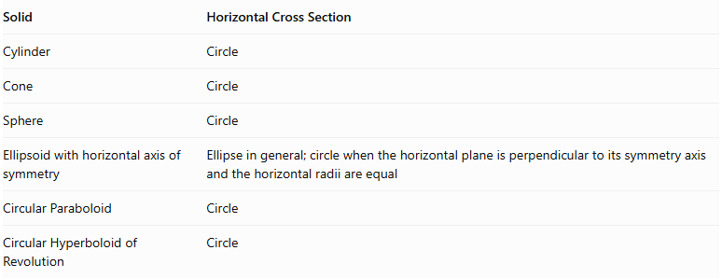
Solid | Horizontal Cross Section
Cylinder | Circle
Cone | Circle
Sphere | Circle
Ellipsoid with horizontal axis of symmetry | Ellipse in general; circle when the horizontal plane is perpendicular to its symmetry axis and the horizontal radii are equal
Circular Paraboloid | Circle
Circular Hyperboloid of Revolution | Circle
Important properties:
- A cylinder produces congruent circular cross-sections parallel to its bases.
- A cone produces circles whose radii vary with height.
- A sphere produces circles whose radii depend on the distance from its center.
- A circular paraboloid produces circular cross-sections whose radii vary with height.

Elliptical Horizontal Cross Section
# Source: AI Source: Provided by: [Data Path: Persons Table -> ID Column: 1, Name_En Column: Motasem Essam] -> From: [ChatGPT] on [7/25/2026]
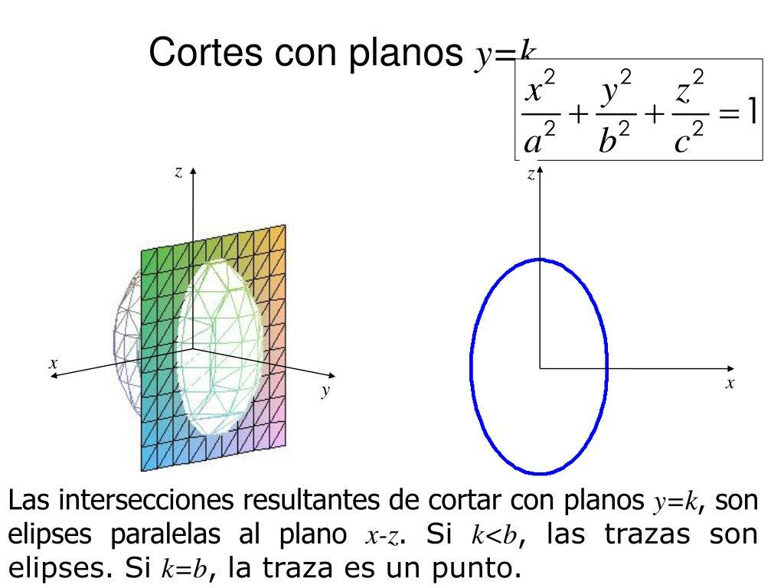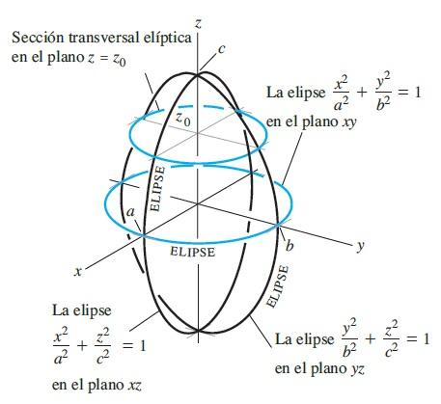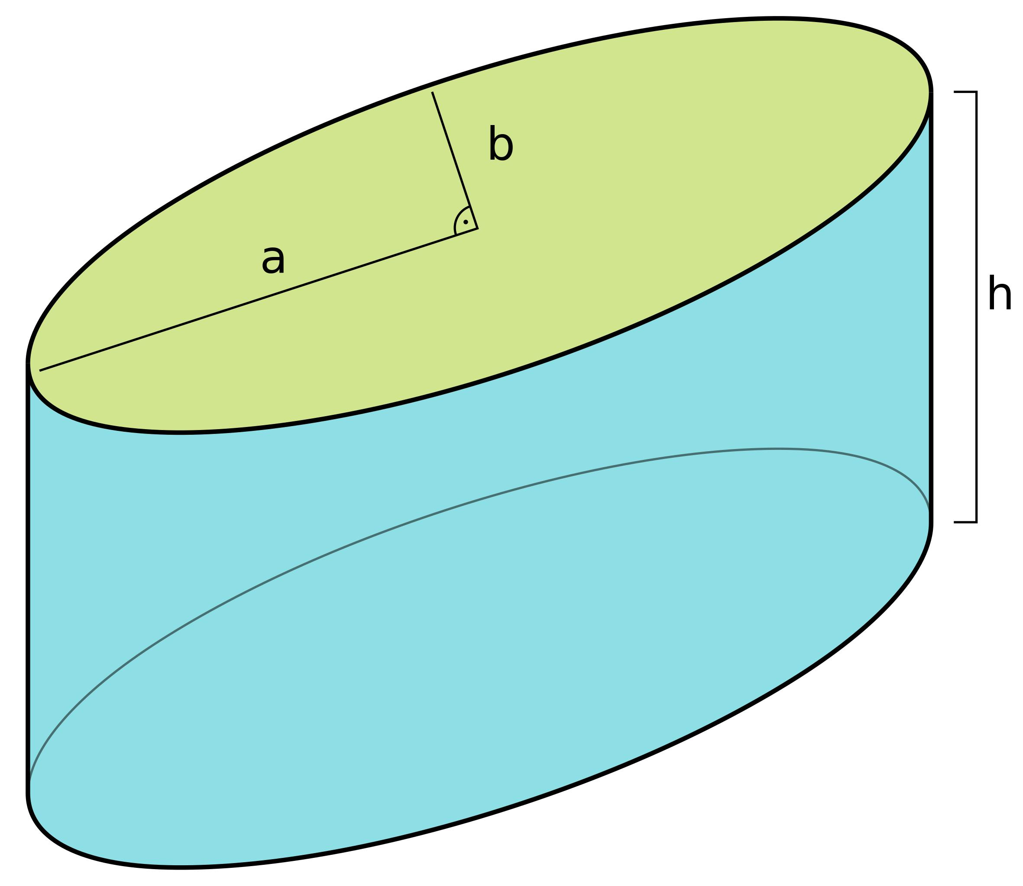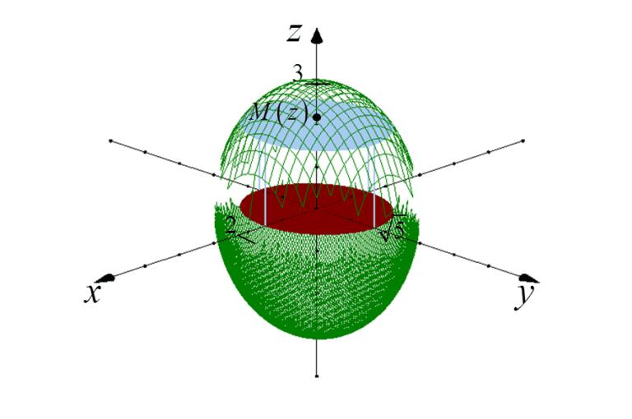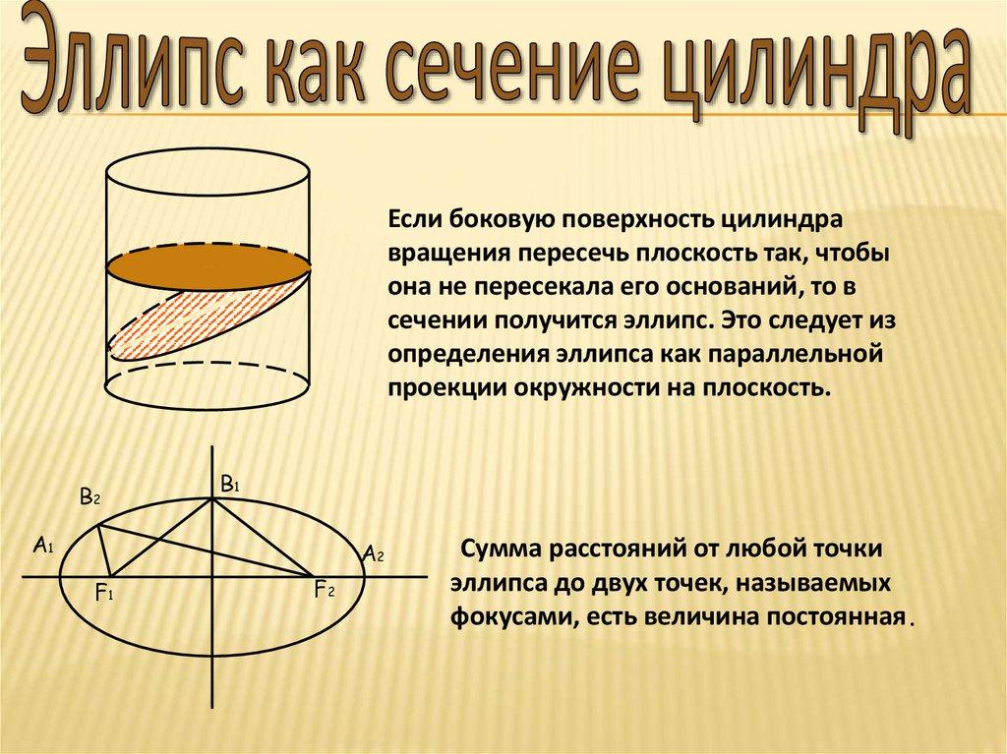
An Elliptical Horizontal Cross Section is formed when a horizontal plane intersects a solid and produces an ellipse.
Examples:
- An ellipsoid with unequal horizontal semi-axes.
- An elliptical cylinder with a horizontal cutting plane perpendicular to its axis.
- An elliptical paraboloid.
- An elliptical hyperboloid.
Ellipse area:
$$A=πab$$
Where:
- $a$ = semi-major axis.
- $b$ = semi-minor axis.

Annular Horizontal Cross Section
# Source: AI Source: Provided by: [Data Path: Persons Table -> ID Column: 1, Name_En Column: Motasem Essam] -> From: [ChatGPT] on [7/25/2026]
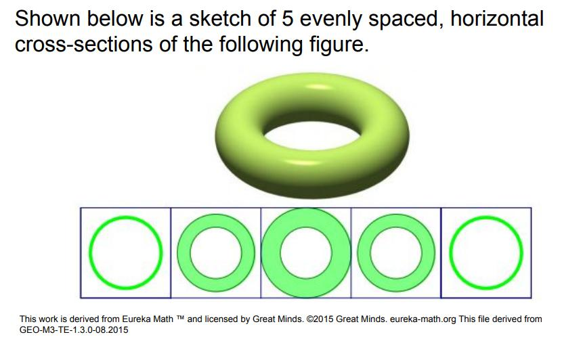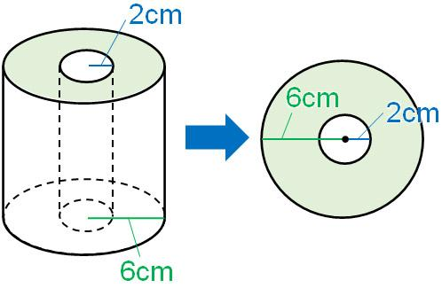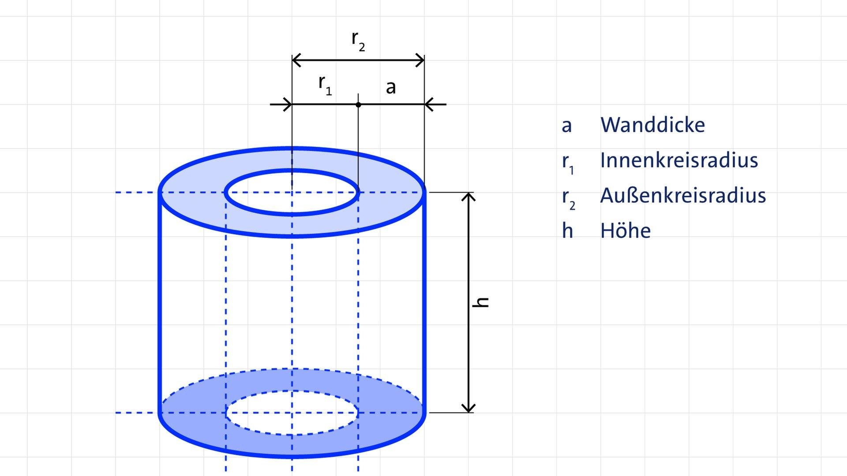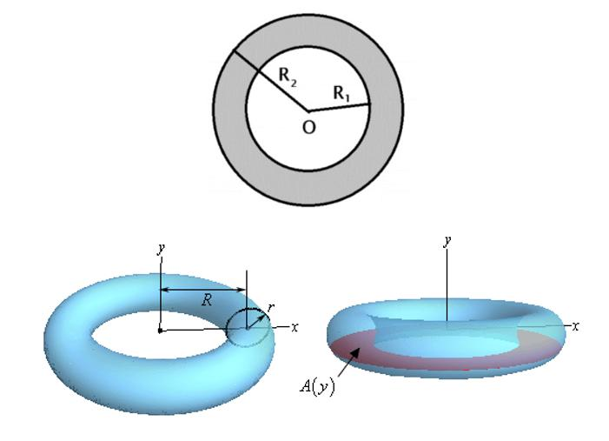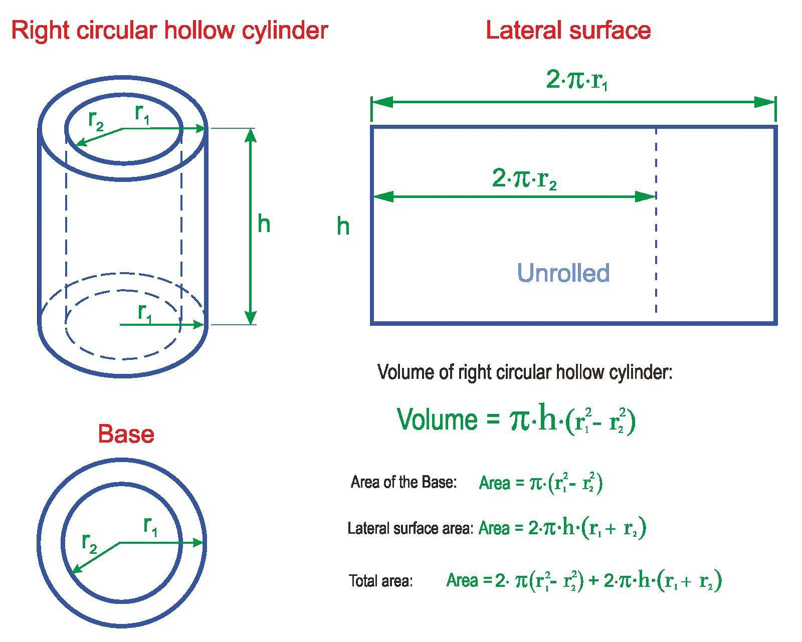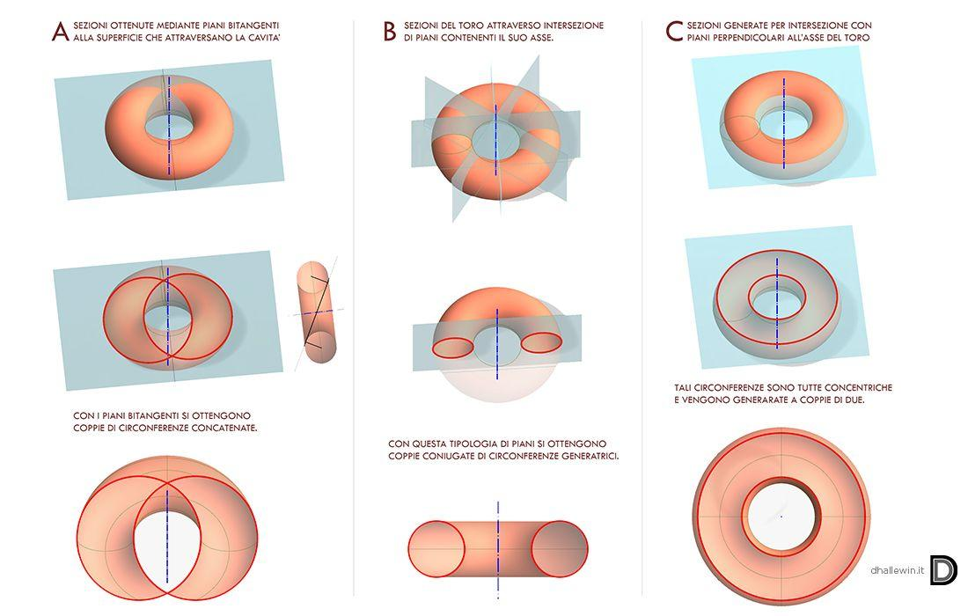
An Annular Horizontal Cross Section is a ring-shaped region formed when a horizontal plane intersects a hollow rotational solid.
Examples:
- A hollow cylinder with a vertical axis.
- A ring torus intersected by a horizontal plane perpendicular to its axis, at suitable heights.
Area:
$$A=π(R^{2}-r^{2})$$
Where:
- $R$ = outer radius.
- $r$ = inner radius.
For a ring torus, the horizontal cross-section is not necessarily a single annulus at every height. Its shape and number of components depend on the cutting height.

Irregular Horizontal Cross Section
# Source: AI Source: Provided by: [Data Path: Persons Table -> ID Column: 1, Name_En Column: Motasem Essam] -> From: [ChatGPT] on [7/25/2026]
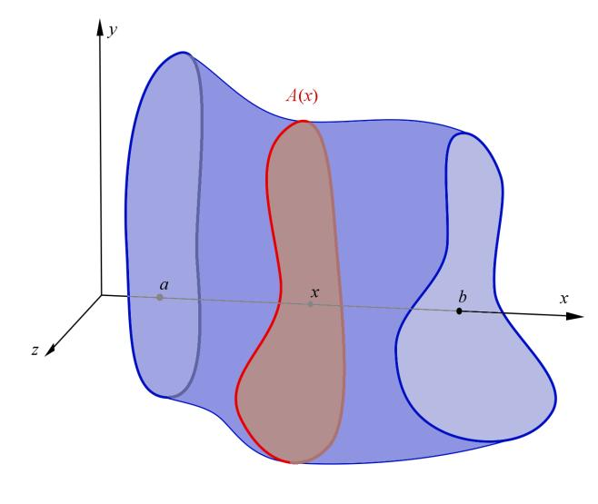
An Irregular Horizontal Cross Section is formed when a horizontal plane intersects an irregular or non-uniform solid and produces a cross-section that does not correspond to a standard geometric shape.
Examples:
- Irregular composite solids.
- Non-uniform architectural structures.
- Irregular solids of revolution.
- Complex natural and manufactured objects.

Horizontal Cross Sections of Common Geometric Solids
# Source: AI Source: Provided by: [Data Path: Persons Table -> ID Column: 1, Name_En Column: Motasem Essam] -> From: [ChatGPT] on [7/25/2026]
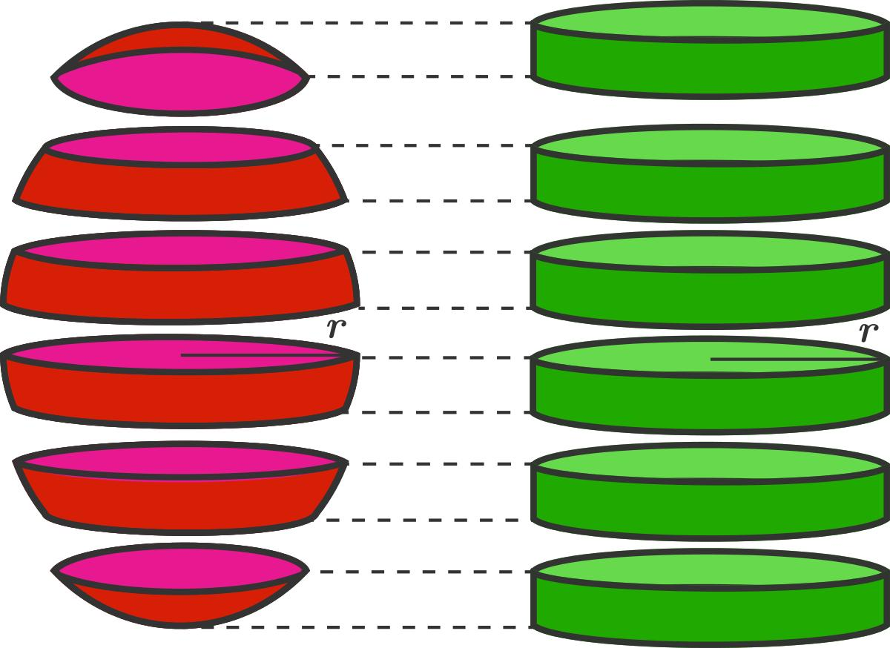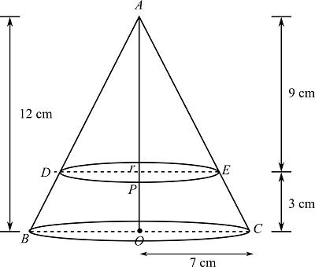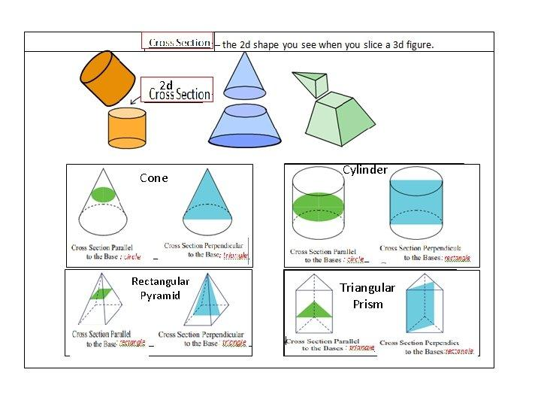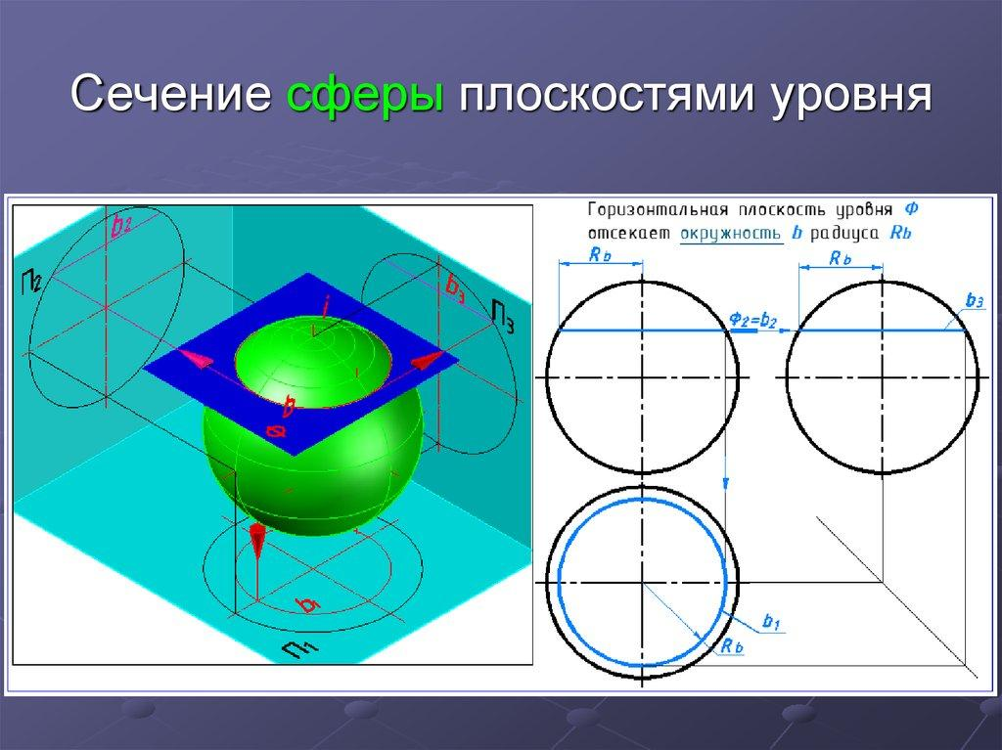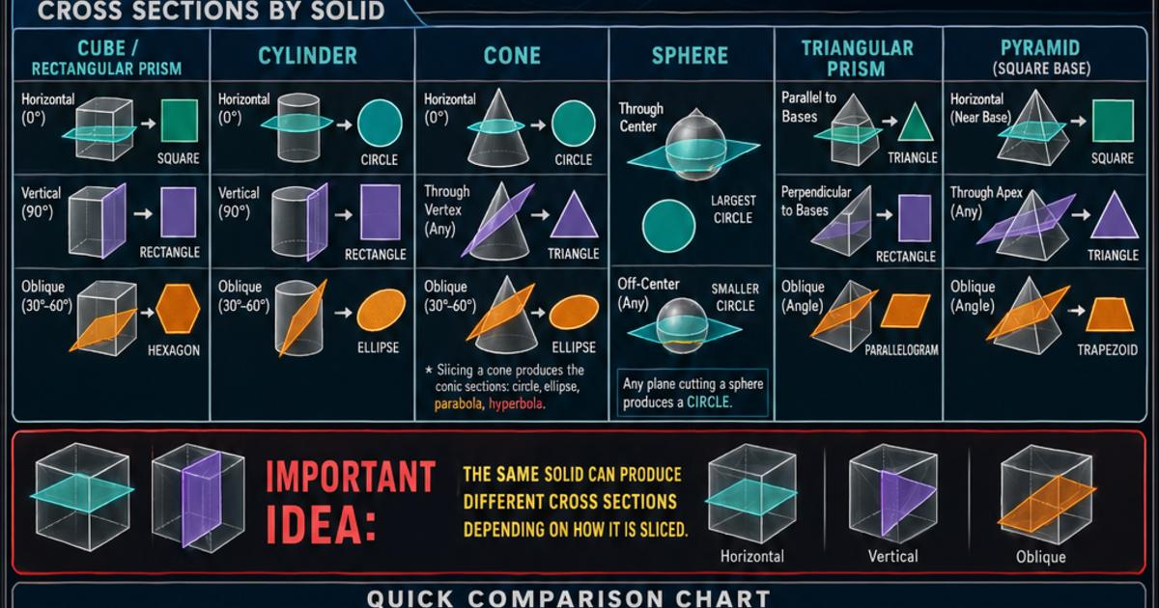
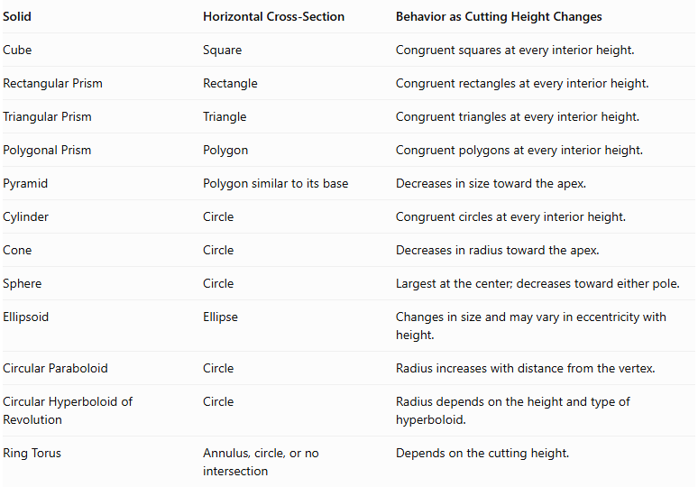
Solid | Horizontal Cross-Section | Behavior as Cutting Height Changes
Cube | Square | Congruent squares at every interior height.
Rectangular Prism | Rectangle | Congruent rectangles at every interior height.
Triangular Prism | Triangle | Congruent triangles at every interior height.
Polygonal Prism | Polygon | Congruent polygons at every interior height.
Pyramid | Polygon similar to its base | Decreases in size toward the apex.
Cylinder | Circle | Congruent circles at every interior height.
Cone | Circle | Decreases in radius toward the apex.
Sphere | Circle | Largest at the center; decreases toward either pole.
Ellipsoid | Ellipse | Changes in size and may vary in eccentricity with height.
Circular Paraboloid | Circle | Radius increases with distance from the vertex.
Circular Hyperboloid of Revolution | Circle | Radius depends on the height and type of hyperboloid.
Ring Torus | Annulus, circle, or no intersection | Depends on the cutting height.
Note: These examples assume the solids are positioned in their conventional upright orientation, with the horizontal plane parallel to the reference base where one exists.

Mathematical Representation

Horizontal Plane Equation
# Source: AI Source: Provided by: [Data Path: Persons Table -> ID Column: 1, Name_En Column: Motasem Essam] -> From: [ChatGPT] on [7/25/2026]
In three-dimensional Cartesian coordinates, a horizontal plane is represented by:
$$\boxed{z=h}$$
Where:
- $z$ = vertical coordinate.
- $h$ = height of the cutting plane.
The plane is parallel to the $xy$-plane.
A horizontal cross-section of a solid $S$ is:
$$\boxed{C_{h}=S∩\{(x,y,z):z=h\}}$$

Cross-Sectional Area of Common Solids
# Source: AI Source: Provided by: [Data Path: Persons Table -> ID Column: 1, Name_En Column: Motasem Essam] -> From: [ChatGPT] on [7/25/2026]
A. Prism
For a prism with base area $A_{b}$:
$$A(h)=A_{b}$$
The cross-sectional area remains constant throughout its height.
B. Pyramid
For a pyramid with base area $A_{b}$, total height $H$, and cutting height $h$ measured upward from the base:
$$\boxed{A(h)=A_{b}{\left(1-\frac{h}{H}\right)}^{2}}$$
This applies to a plane parallel to the base, for $0≤h≤H$.
C. Cylinder
For a right circular cylinder with radius $r$:
$$\boxed{A(h)=πr^{2}}$$
D. Cone
For a right circular cone with base radius $R$, height $H$, and cutting height $h$ measured upward from the base:
$$r(h)=R\left(1-\frac{h}{H}\right)$$
Therefore:
$$\boxed{A(h)=πR^{2}{\left(1-\frac{h}{H}\right)}^{2}}$$
E. Sphere
For a sphere with radius $R$, with its center at height $z=0$:
$$r(h)=\sqrt{R^{2}-h^{2}}$$
Therefore:
$$\boxed{A(h)=π(R^{2}-h^{2})}$$
For $-R≤h≤R$.
F. Ellipsoid
For an ellipsoid centered at the origin:
$$\frac{x^{2}}{a^{2}}+\frac{y^{2}}{b^{2}}+\frac{z^{2}}{c^{2}}=1$$
A horizontal cross-section at $z=h$ is an ellipse:
$$\frac{x^{2}}{a^{2}(1-h^{2}/c^{2})}+\frac{y^{2}}{b^{2}(1-h^{2}/c^{2})}=1$$
Its area is:
$$\boxed{A(h)=πab\left(1-\frac{h^{2}}{c^{2}}\right)}$$
For $|h|≤c$.

Volume Using Horizontal Cross Sections
# Source: AI Source: Provided by: [Data Path: Persons Table -> ID Column: 1, Name_En Column: Motasem Essam] -> From: [ChatGPT] on [7/25/2026]
The volume of a solid can be calculated by integrating its horizontal cross-sectional areas over its height:
$$\boxed{V=\int_{h_{1}}^{h_{2}}{A(h)} dh}$$
Where:
- $A(h)$ = horizontal cross-sectional area at height $h$.
- $h_{1}$ = lower height.
- $h_{2}$ = upper height.
This is known as the Method of Cross Sections or Slicing Method.

Mathematical Properties
# Source: AI Source: Provided by: [Data Path: Persons Table -> ID Column: 1, Name_En Column: Motasem Essam] -> From: [ChatGPT] on [7/25/2026]
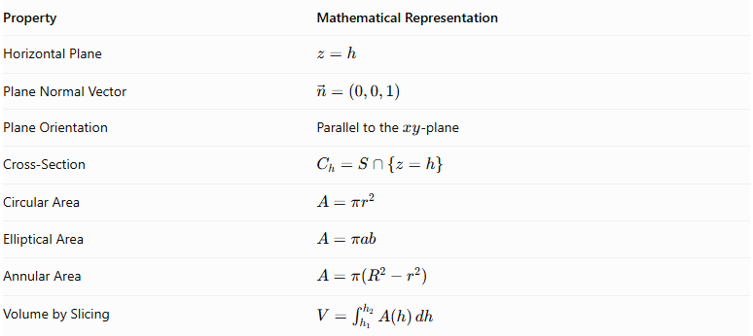
Property | Mathematical Representation
Horizontal Plane | $$z=h$$
Plane Normal Vector | $$vecn=(0,0,1)$$
Plane Orientation | Parallel to the $xy$-plane
Cross-Section | $$C_{h}=S∩\{z=h\}$$
Circular Area | $$A=πr^{2}$$
Elliptical Area | $$A=πab$$
Annular Area | $$A=π(R^{2}-r^{2})$$
Volume by Slicing | $$V=\int_{h_{1}}^{h_{2}}{A(h)} dh$$

Geometric Applications
# Source: AI Source: Provided by: [Data Path: Persons Table -> ID Column: 1, Name_En Column: Motasem Essam] -> From: [ChatGPT] on [7/25/2026]
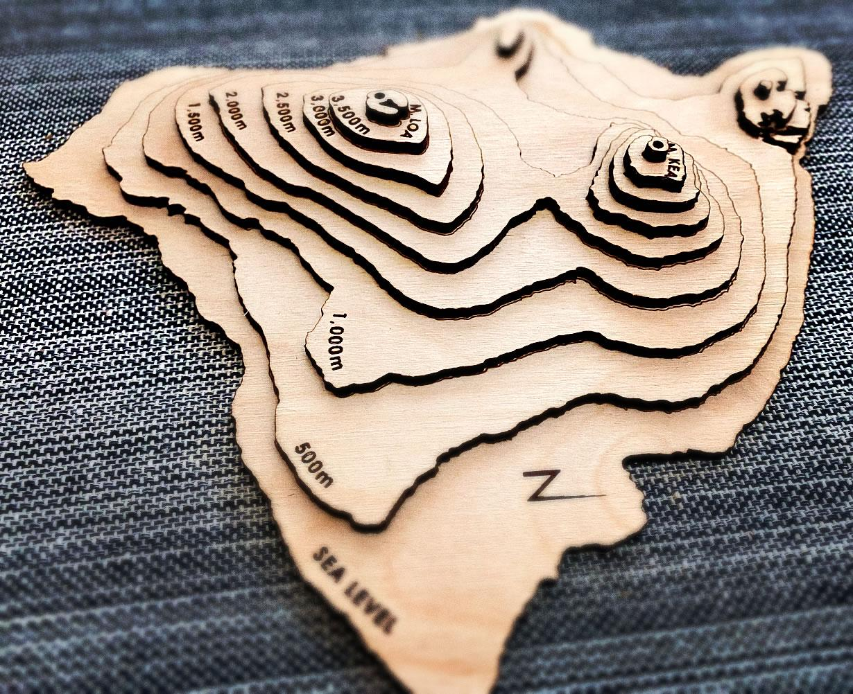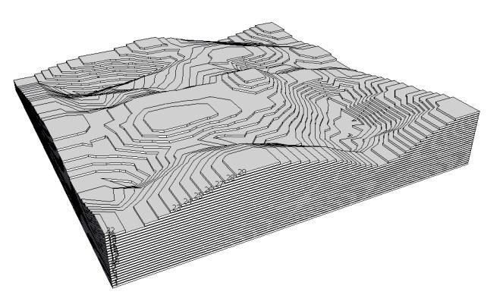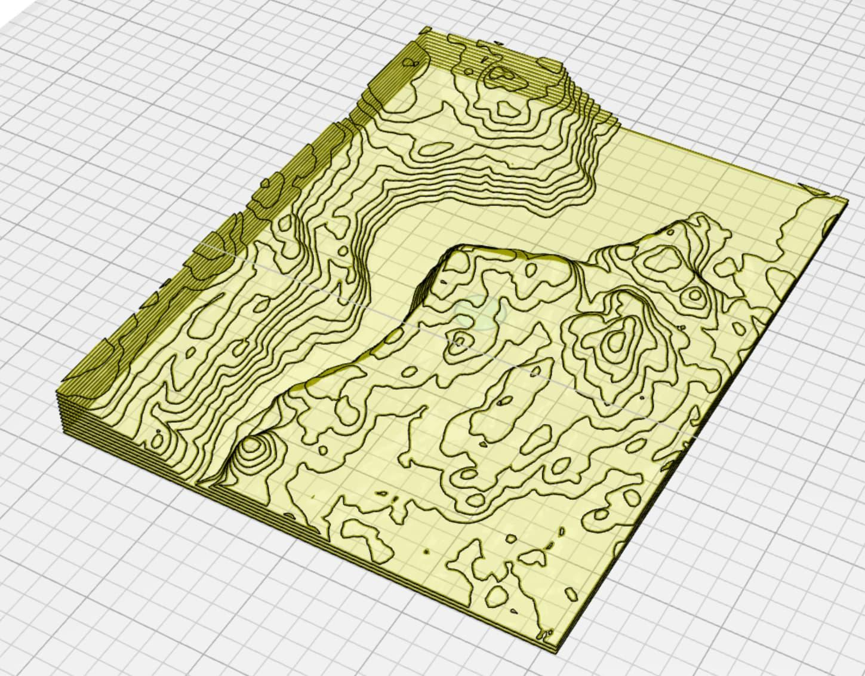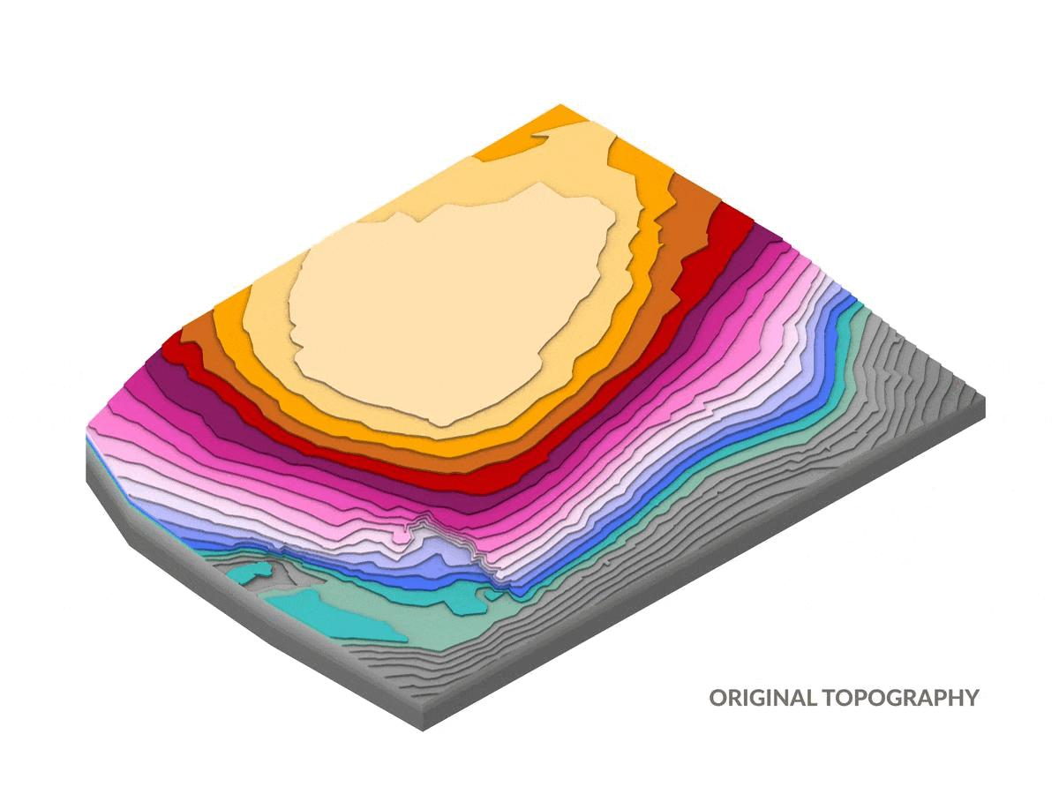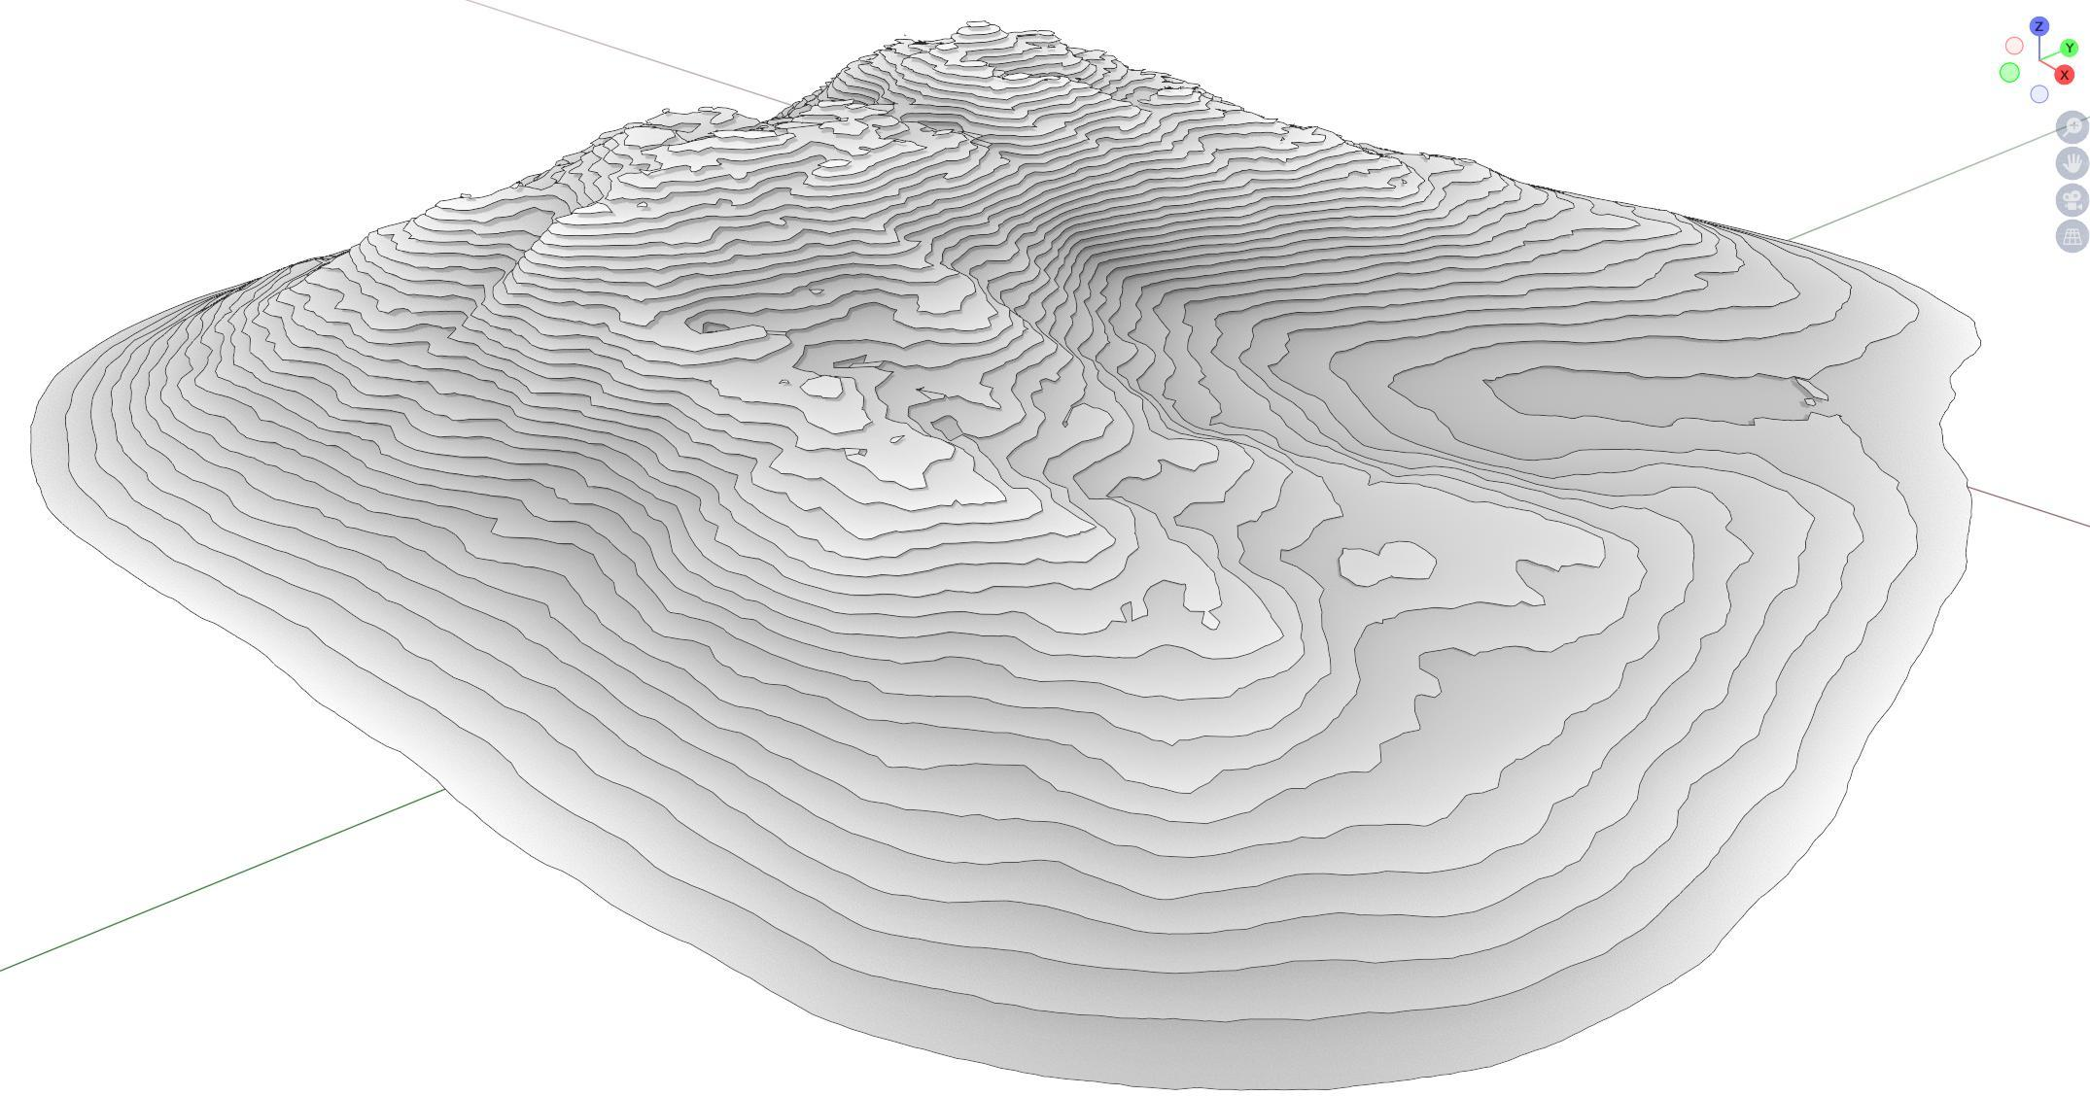
- Architecture: Studying floor plans and horizontal sections at different building heights.
- Engineering: Examining the dimensions of structural components at different elevations.
- Medical Imaging: Analyzing axial CT and MRI slices.
- Geology: Studying horizontal layers and underground structures.
- Manufacturing: Measuring cross-sectional dimensions of components.
- Mathematics: Calculating volumes through integration of horizontal cross-sectional areas.

Main Classification
# Source: AI Source: Provided by: [Data Path: Persons Table -> ID Column: 1, Name_En Column: Motasem Essam] -> From: [ChatGPT] on [7/25/2026]
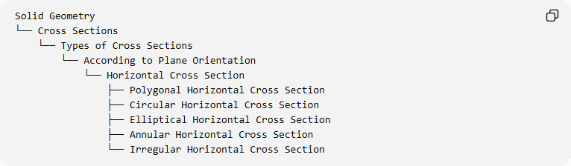
Solid Geometry
└── Cross Sections
└── Types of Cross Sections
└── According to Plane Orientation
└── Horizontal Cross Section
├── Polygonal Horizontal Cross Section
├── Circular Horizontal Cross Section
├── Elliptical Horizontal Cross Section
├── Annular Horizontal Cross Section
└── Irregular Horizontal Cross Section

Key Points
# Source: AI Source: Provided by: [Data Path: Persons Table -> ID Column: 1, Name_En Column: Motasem Essam] -> From: [ChatGPT] on [7/25/2026]
- A horizontal cross-section is produced by intersecting a solid with a horizontal plane.
- In the conventional coordinate system, its plane equation is $z=h$.
- Horizontal cross-sections are generally parallel to the base of an upright solid.
- Prisms and cylinders have constant cross-sectional areas at every interior height.
- Pyramids and cones have progressively smaller cross-sections toward their apexes.
- Spheres have their largest horizontal cross-section through the center.
- Ellipsoids generally produce elliptical horizontal cross-sections.
- Cross-sectional areas can be integrated to calculate the volume of a solid.

Conclusion
# Source: AI Source: Provided by: [Data Path: Persons Table -> ID Column: 1, Name_En Column: Motasem Essam] -> From: [ChatGPT] on [7/25/2026]
A Horizontal Cross Section is an important type of cross-section in solid geometry, formed by intersecting a three-dimensional solid with a horizontal plane. Its geometric shape and dimensions depend on the solid's structure and the height at which the plane intersects it.
Horizontal cross-sections are particularly useful for studying prisms, pyramids, cylinders, cones, spheres, and other curved solids. They also provide an essential mathematical foundation for calculating solid volumes using the method of cross sections.

